Helping parent Carers to navigate the journey of supporting a child with Special Educational Needs and Disabilities
What are Special Educational Needs (SEN)
𝐓𝐡𝐞 𝐒𝐄𝐍 𝐂𝐨𝐝𝐞 𝐨𝐟 𝐏𝐫𝐚𝐜𝐭𝐢𝐜𝐞, 𝐝𝐢𝐬𝐚𝐛𝐢𝐥𝐢𝐭𝐲 𝐥𝐞𝐠𝐢𝐬𝐥𝐚𝐭𝐢𝐨𝐧 𝐚𝐧𝐝 𝐫𝐨𝐥𝐞 𝐨𝐟 𝐭𝐡𝐞 𝐒𝐄𝐍𝐂𝐨
Section 20 Children and Families Act 2014 defines a child as having Special Educational Needs (SEN) if he or she "has a learning difficulty or disability which calls for special education provision to be made for him or her".
A child is considered to have a learning difficulty if she or he:
- has a significantly greater difference in learning than the majority of others of the same age; or
- has a disability which prevents or hinders them from making use of facilities of a kind generally provided for others of the same age in mainstream schools or mainstream post 16 settings.
In the Equality Act 2010 a person is classed as disabled if they have a physical or mental impairment that has a substantial and long-term adverse effect on a person’s ability to carry out typical day-to-day activities.
- typical day-to-day means things that people do on a regular basis, for example mobility, dressing or cleaning (physical co-ordination), and having a conversation.
- Long-term usually means the impairment should have lasted or be expected to last at least a year.
- Substantial means not minor or trivial.
- Physical impairment includes sensory difficulties such as visual or hearing impairments
- Mental impairment includes learning difficulties, autism, dyslexia, speech and language difficulties, attention deficit hyperactivity disorder (ADHD).
Some examples of SEN are:
- Social, emotional and mental health differences (SEMH);
- Autism;
- Attention Deficit (Hyperactivity) Disorder (ADHD/ADD);
- Specific learning differences such as Dyslexia;
- Obsessive Compulsive Disorder;
- communication differences;
- medical needs such as Epilepsy and Cerebral Palsy;
- mobility differences.
If your child has SEN, they may need extra help in a range of areas, for example:
- reading, writing, mathematics or understanding information;
- expressing themselves or understanding what others are saying;
- making friends or relating to adults;
- behaving according to the school rules;
- organising themselves;
- sensory or physical needs which may affect them in school.
What can nurseries do to support your child aged 0-5 years?
All state-maintained nurseries must use best endeavours to ensure that the SEN of children attending the nursery are identified and met as quickly as possible. The nursery should have a detailed SEN policy about the support available.
What can schools do to meet the needs of children with Special Educational Needs?
Every school is required to have systems in place to identify children who are in need of support and to assess, monitor and secure appropriate support for any SEN they may have. Under paragraph 6.2 of the "Special educational needs and disability code of practice: 0 to 25 years", each school must:
- use their best endeavours to make sure that a child with SEN gets the support they need – this means doing everything they can to meet children and young people’s SEN;
- ensure that children and young people with SEN engage in the activities of the school alongside pupils who do not have SEN;
- designate a teacher to be responsible for co-ordinating SEN provision – the SEN co-ordinator, or ‘SENCO’ (not applicable to 16 to 19 academies);
- inform and involve parents when they are making special educational provision for a child;
- prepare a SEN information report and setting out:
  - their arrangements for the admission of disabled children;
  - the steps being taken to prevent disabled children from being treated less favourably than others;
  - the facilities provided to enable access to the school for disabled children; and
  - their accessibility plan showing how they plan to improve access progressively over time.
Schools are required to involve children, young people and their parents in the process, including co-production of the provision plan for the child.
Schools are provided with additional money to provide support for children with SEN, this is called their delegated budget. Each child with SEN is entitled to receive up to £6,000 funding from their school per year.
There are 2 stages of support for meeting the needs of children with SEN: Additional SEN Support and an Education, Health and Care Plan (EHCP).

What is Special Educational Provision?
Special educational provision is provision that is different from or additional to that normally available to pupils or students of the same age, which is designed to help children and young people with SEN or disabilities to access the National Curriculum at school or to study at college.
For children under 2 years old it is educational provision of any kind.
What can the school governing body do to meet the needs of children with SEN?
- Develop and monitor the School’s SEN policy.
- Ensure that all governors, especially SEN governors, are up to date and knowledgeable about the school’s SEN provision, including how funding, equipment and personnel resources are deployed.
- Ensure that SEN provision is an integral part of the school’s development plan.
- Ensure that the school’s notional SEN budget is appropriately allocated to support pupils with SEN.
Additional SEN support
SEN Support in Schools A graduated approach - YouTube
Hear from children and young people, what SEND Support and the graduated approach means.
If a child is identified as struggling with their school work, and it is determined that this is being caused by a child’s underlying SEN, it may be necessary for a school to intervene to provide additional support for that child.
This support should be provided through a process known as ‘Additional SEN Support’. This is designed to help remove any barriers the child has to learning and put in place provision that will enable that child to benefit fully from their education.
This support should be provided through a continuously repeated 4-part cycle known as the ‘graduated approach’, revisiting and reappraising the support, and concentrating on what works best for the child. In this way, the support should become more refined and specialised over time, to ensure that the child continues to make good progress at school and that the desired outcomes are reached.
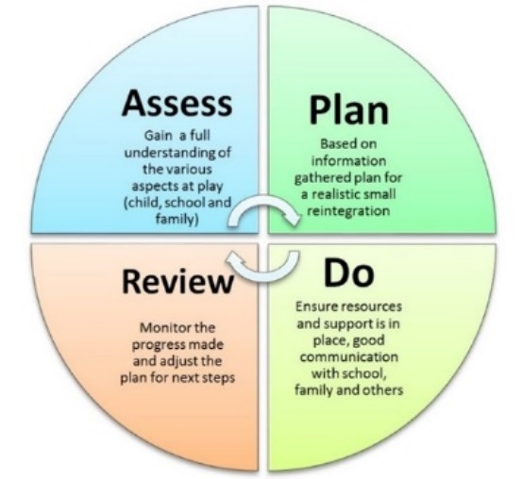
The 4-part cycle is as follows:

1. Assess
This is when a child’s class or subject teacher along with the school’s SENCO work together to carry out a clear analysis of a child’s needs. This assessment process should not just involve the school themselves, the views of parent carers should also be sought and where appropriate the views of the child or young person. Where outside professionals are also involved with the child or young person, for example Children’s Services or health professionals, it may also be appropriate to seek their views. This assessment should be reviewed on a regular basis to make sure that the support being provided to a child continues to be effective and best matched to the child’s needs.
2. Plan
Where a school does decide to put in place Additional SEN support for a child, the parent carers should be formally notified of this. The child’s teachers and the school’s SENCO should then, in consultation with the parent carers and the pupil if appropriate, agree on the following:
- the adaptations, adjustments, interventions and support to be put in place;
- the expected impact on progress, development or behaviour;
- the desired outcomes for the child; and
- a clear date for review
All teachers and support staff that work with the child should be made aware of the child’s needs and of the above plan, so they can make sure the ‘Plan’ is correctly implemented. The ‘Plan’ should also be placed on the child’s school record and should be accessible by parents.
3. Do
The child’s class teacher still remains responsible for planning for and working with the child on a day-to-day basis; this remains the case even if the support offered includes group or one to one teaching away from the child’s main class. This should all be done whilst working closely with any support or specialist staff involved.
The SENCO should remain closely involved in supporting the child’s class teacher, both in terms of continuing to assess the child’s progress and needs and ensuring the planned support is being implemented properly.
4. Review
The success and effectiveness of the support provided should be reviewed on a regular basis and in line with the date agreed in the ‘Plan’ stage. During this ‘Review’ stage, the impact and quality of the support in place should be evaluated and the views of the parent carers and child should again be sought.
This review process should inform Part 1 of the cycle – the needs should again be assessed and the cycle should flow through again, with any changes needed to the support provided being implemented.
A spokesperson for the Department for Education has recommended that reviews with parent carers should take place at least 3 times a year.
What can the Local Authority do to meet the needs of children with SEN?
What is the local offer for children and young people with Special educational Needs?
The Local Offer aims to bring together useful information across education, health and social care within one website. You can find information, advice and guidance and a range of local service providers who support children and young people with Special Educational Needs and Disabilities (SEND).
SEND - Local offer - Telford

The SEND local offer | Shropshire Council – Shropshire

- Identify, assess and provide for children with SEN.
- Audit, plan, monitor and review SEN provision.
- Provide support through an information, support and advice service (IASS) for young people with SEN.
- Liaise with other partners whose job it is to support children with SEN (such as schools, colleges, and health bodies).
- Secure training, advice and support for staff working with SEN.
What happens if the support being provided through Additional SEN Support is not enough?
What is an EHCP? Understanding EHCPs in Schools - Education CPD and Advice
A quick guide for parents and carers to the Education Health Care Plan (EHCP) process
https://www.youtube.com/watch?v=axMjmY1-7WU
Education Health and Care Plan (EHCP) Needs Assessment Process
An education, health and care (EHC) plan is for children and young people aged up to 25 who need more support than is available through special educational needs support.
EHC plans identify educational, health and social needs and set out the additional support to meet those needs.
If the parent carers of a child do not believe that the support being provided to their child through Additional SEN Support is allowing the identified outcomes to be reached, they should first raise their concerns with the school’s SENCO – this should be done prior to the ‘Review’ stage. There is scope within Additional SEN Support for external specialists to become involved to support the child – for example, this could include:
- Behaviour Support Services;
- Educational Psychologist;
- Child and Adolescent Psychologists;
- Speech and Language Therapists;
- Occupational Therapists;
- Children and Young People’s Mental Health Services (CYMHS).
Parent carers have the right to be present at any interview, medical or other test during the statutory assessment, but sometimes the professionals may ask to see the child without a parent carer present. The parent carers should feel free to suggest any other people or organisations they know whose views may be helpful in the assessment of a child.
If the SEN support provided by the school is not achieving the agreed outcomes, then it can be adapted or replaced with new forms of support. If the school has taken relevant and purposeful action but the child is still not making the expected progress then the school or the parent carers can pursue an Education, Health and Care Plan (EHCP) for the child. To initiate this process, they can apply for an EHC needs assessment. An EHC needs assessment is an assessment of the educational, health care and social care needs of a child or young person.
When deciding whether to carry out an EHC needs assessment the Local Authority will consider:
- evidence of the child or young person’s academic attainment (or developmental milestones in younger children) and rate of progress
- information about the nature, extent and context of the child or young person’s SEN
- evidence of the action already being taken by the early years’ provider, school or post-16 institution to meet the child or young person’s SEN
- evidence that where progress has been made, it has only been as the result of much additional intervention and support over and above that which is usually provided
- evidence of the child or young person’s physical, emotional and social development and health needs, drawing on relevant evidence from clinicians and other health professionals and what has been done to meet these by other agencies

How can I raise concerns as a Parent Carer?
1. Speak to the child’s teacher
If you have concerns with regards to your child’s education and you feel that they are not coping with their school work, you should raise your concerns with your child’s teacher. This may be their class teacher or head of year.
At this meeting, you may wish to provide evidence to the teacher supporting your concerns. This could include homework, test results and any other work. You may also wish to discuss with the teacher any change you have noticed in your child, such as them becoming more anxious, their behaviour deteriorating or any health condition that has been recently diagnosed.
During this meeting, you and the teacher should try and work together to address any concerns and to decide whether any action needs to be taken. It is important that you make note of any recommendations made and any plan that is being implemented. You should then make another meeting date, to follow up on any implementations that have been suggested.
After this meeting, it is important that you keep a track of how your child is progressing. If you do not feel that any progress has been made, you should meet with the teacher again or consider the next step.
2. Have a meeting with the SENCO
Every school must have a SEN Co-ordinator (SENCO). A SENCO has to be a qualified teacher and may also have another job title within the school, such as class teacher, Assistant Headteacher, Deputy Head Teacher or Headteacher.
The role of the SENCO is to ensure that all the special needs provision are met at the school. If you and the school are concerned that your child is still not making any progress, a meeting with the SENCO should be arranged. You can make a written request to the SENCO, requesting a meeting and setting out your concerns. At this point, you may wish to request a copy of the school’s policy on SEN and also your child’s school records, to assess whether you feel the school are fulfilling their duty.
When you have a meeting with the SENCO, you will want to discuss whether the SENCO feels your child has any SEN and the support that the school can provide for them.
It will be at this point that Additional SEN Support could be discussed with you. You and the SENCO should work together to put in place any targets or desired outcomes for your child. It is important that you make a note of anything agreed at this meeting as well.
If you feel it is necessary, you can also ask the school if they can arrange any assessments from outside specialists, such as Speech and Language Therapists or Educational Psychologists.
As discussed above, any support provided through Additional SEN Support should be reviewed regularly to ensure that outcomes are being met by your child and that they are receiving the support necessary. If this isn’t the case, you may wish to follow the next stage below.

Who can support me?

Making a Difference Why should I join my local Parent Carer Forum - YouTube
Find out why joining your local Parent Carer forum to have your voice heard for all things linked to Special Educational Needs.
If you have a child living in Telford and Wrekin, your local Parent Carer Forum can be found here - Together We Can Make a Difference. Please see below a message from Jayne Stevens – Strategic Lead for Parents Opening Doors (PODS).

Working together with parents and carers - our approach to support children & young people with SEND
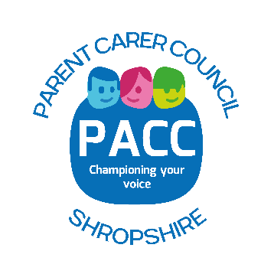
If you have a child living in Shropshire, your local Parent Carer Forum can be found here - Parent Carer Council Shropshire (PACC) Please see below a message from Sarah Thomas – Influence & Change Strategic Lead for PACC.

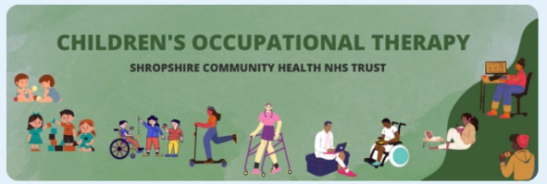
Children’s Occupational Therapy (OT)
The OT service can provide advice and support children who have functional difficulties
https://www.shropscommunityhealth.nhs.uk/childrens-occupational-therapy
https://www.shropscommunityhealth.nhs.uk/chot-senses
https://www.shropscommunityhealth.nhs.uk/chot-senses-resources

School Nurse
The school nursing service works closely health visitors to support children and their families from age 5 to Post 16 (or 25 for those with SEN). See the following link for more information on the services they offer: Shropshire School Nurses

Speech and Language Therapy (SaLT)
The SaLT team can support and young peoples speech, language and communication and their eating.
Find out more about the SaLT teams services here: Speech & language therapy
SENDIASS - Shropshire
About Us | Shropshire Sendiass
Discover how Shropshire SENDIASS supports children, young people (0-25) with SEND, and their families. We provide free, impartial, and confidential information, advice, and support on education, health, and social care. Learn about our services, how we can help, and how to get in touch. Visit www.shropshiresendiass.com to find out more.

SENDIASS – Telford
Who are we and what do we do?
We're here for you . . .
- If you're a parent/carer of a child or young person with special educational needs or a disability
- If you're a young person with special educational needs or a disability 16-25
- If you have an issue or concern in the areas of education, health or social care
- If you live in Telford and Wrekin
- If you think your child has or may have a special educational need
To find out more visit - Telford SENDIASS | SENDIASS Telford


